1-Draw Airline booking system for use case diagram in Star UML

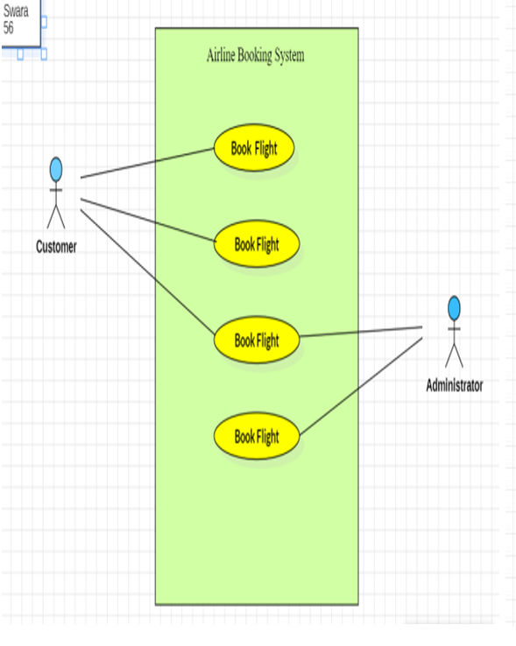

2-Draw Researcher system for use case diagram in Star UML

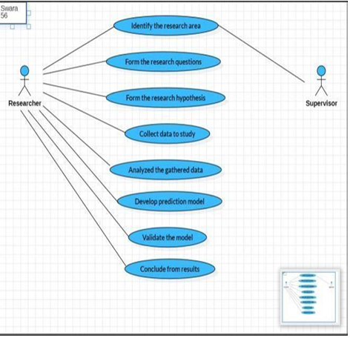

3-Draw Library user system for use case diagram in Star UML

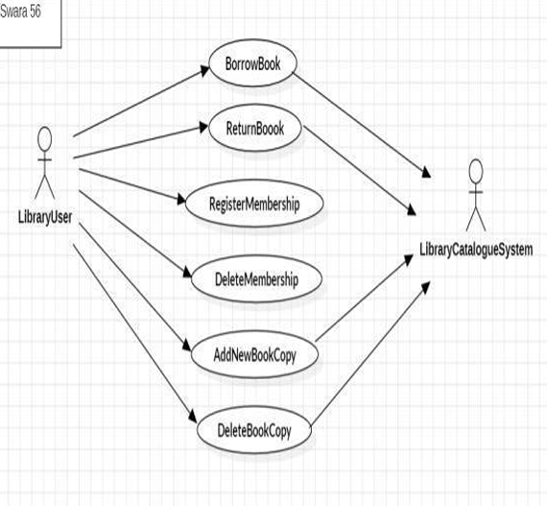

4-Draw Employee management system for activity diagram in Star UML

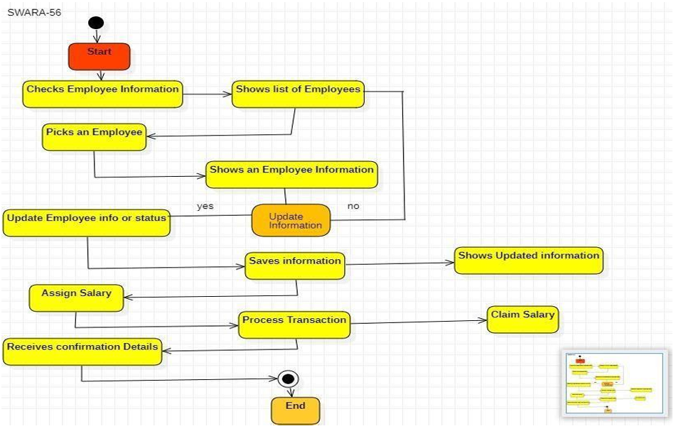

5-Draw Bank withdrawal system for activity diagram in Star UML

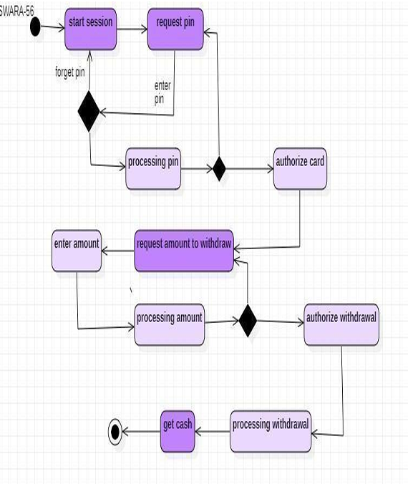

6-Draw Library system for activity diagram in Star UML

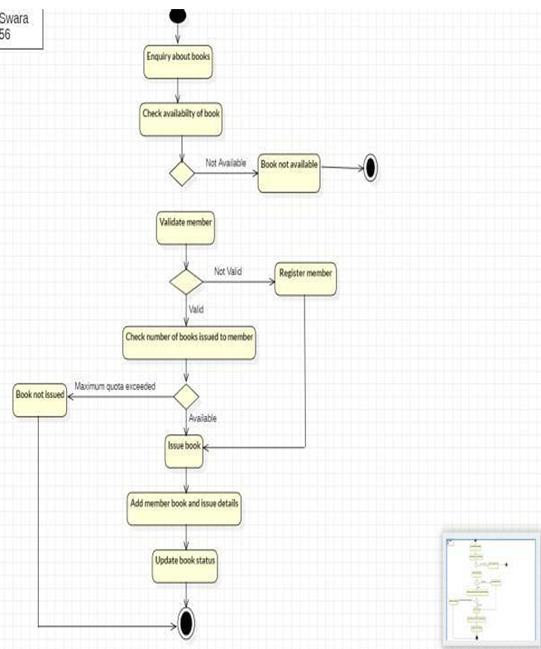

7-Draw Client login password server system for activity diagram in Star UML

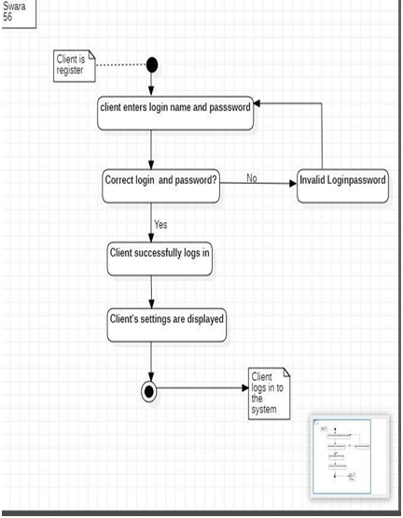

8- Library Management system for ER-diagram in Star UML

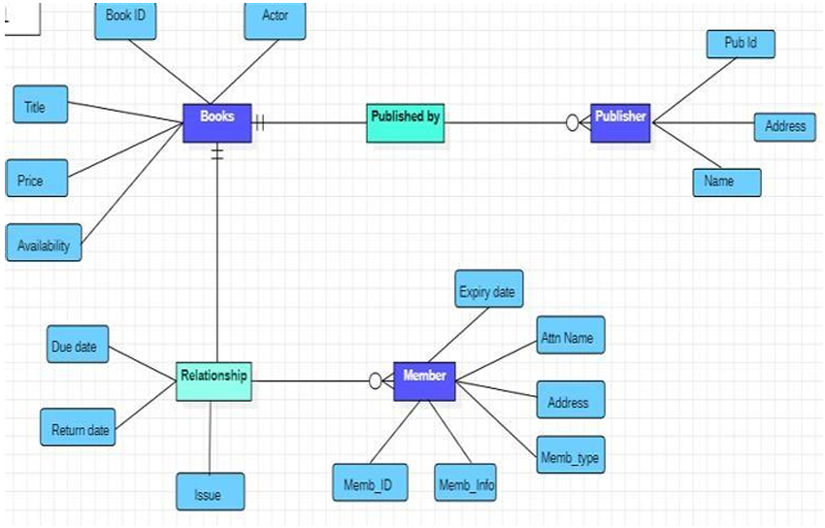

9-Draw Student Management system for ER-diagram in Star UML

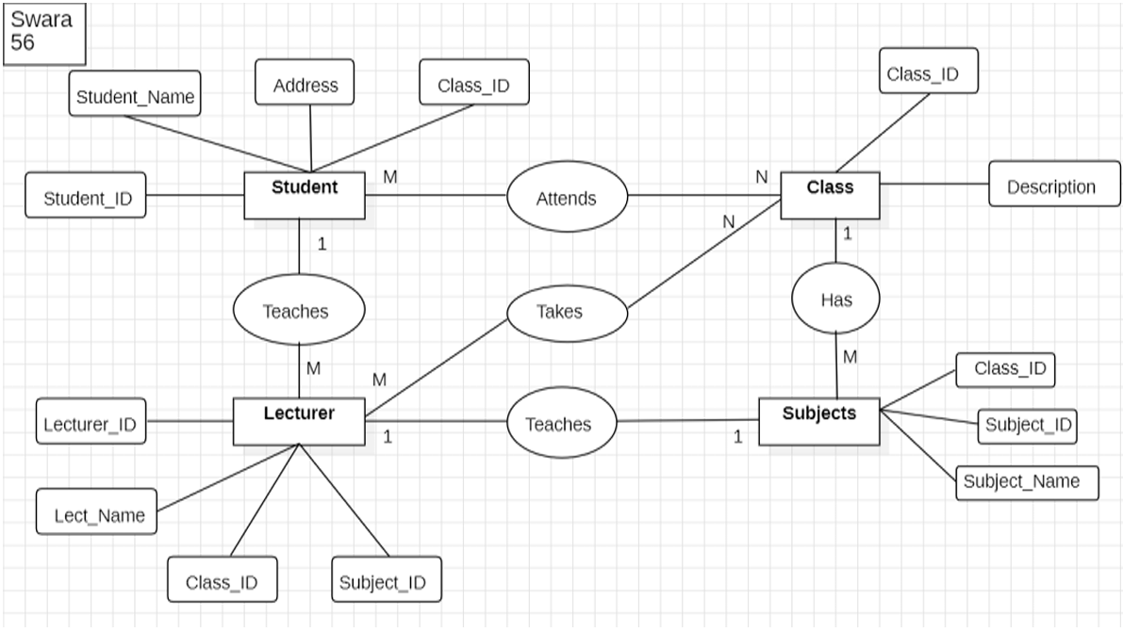

10-Draw Travel Agency system for ER-diagram in Star UML

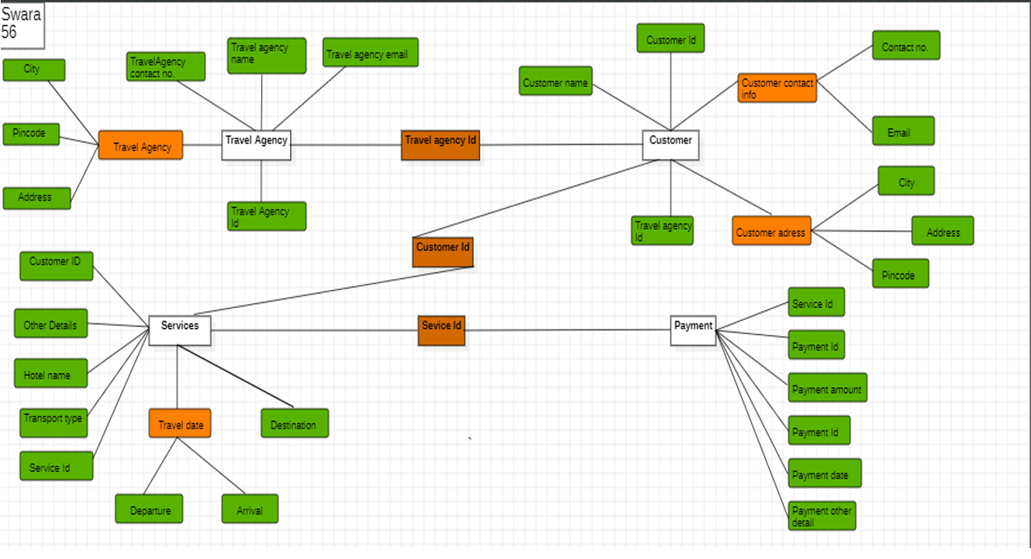

11- Draw Employee Management system for ER-diagram in Star UML.

